**ATAR HUMAN BIOLOGY – UNIT 1**

**TASK 3 – METABOLISM, CIRCULATORY AND RESPIRATORY SYSTEMS TEST**

**NAME: _________________________________ WEIGHTING: 5%**

**DUE DATE: _________________________________ MARK: ______ /57 = ______ %**

Important Information for Students

1. There are THREE sections in this test - Multiple Choice, Short Answer and Extended Answer.
2. This is a closed-book assessment (no notes are allowed)
3. The time allowed to complete the test is 60 minutes.
4. Write your answers to the Multiple Choice section on the **separate** answer sheet provided. Circle only 1 answer.
5. Write your answers to the Short Answer section in space provided.
6. Write your answers to the Extended Answer section in space provided

|  |  |  |
| --- | --- | --- |
| Sections | **Marks Allocation** | **Your Total** |
| **A - Multiple Choice** | 9 |  |
| **B - Short Answer** | 38 |  |
| **C - Extended Answer** | 10 |  |
| **TOTAL** | **57** |  |

**Multiple Choice Answer Sheet**

Answer all questions by placing a circle around the correct letter.

1. A B C D

2. A B C D

3. A B C D

4. A B C D

5. A B C D

6. A B C D

7. A B C D

8. A B C D

9. A B C D

**MULTIPLE CHOICESECTION [9 MARKS]**

1. The trachea contains cells that have cilia. What is the function of the cilia?
   1. To give shape to the trachea
   2. To help move the gases to and from the lungs
   3. To move mucus and trapped particles out
   4. To increase the surface area of the trachea
2. As blood enters the capillaries, the relatively high pressure forces some of the fluid in the blood in through the capillary walls into the tissues. How is this fluid returned to the heart?
   1. The effect of gravity on the body returns the fluid to the heart
   2. Osmosis returns the fluid to the heart
   3. Combination of contracting muscles and valved vessels of the lymphatic system
   4. Fibrin and serum capture the fluid and return it to the heart
3. If a person has a heart rate of 70 beats per minute and a cardiac output of 1400ml per minute then their stroke volume would be:
4. 20mls
5. 200mls
6. 100mls
7. 70mls
8. Which of the following is true of gaseous exchange through the walls of the alveoli?
9. Net diffusion of oxygen is from the alveoli to the blood capillaries.
10. Diffusion of carbon dioxide occurs at the same rate in both directions.
11. Net diffusion of carbon dioxide is from the alveoli to the blood capillaries.
12. Diffusion of oxygen occurs at the same rate in both directions.
13. The process in which a substance spreads from an area of high concentration to an area of low concentration is:  
    1. exocytosis
    2. facilitated diffusion
    3. active transport
    4. pinocytosis
14. Alien Hand Syndrome is neurological disorder caused by a stroke and damage to the parietal lobe. The brain tissue is deprived of oxygen. Select what will happen to Adenosine Triphosphate (ATP) formation after oxygen has been deprived.  
    1. Metabolism increases as the cells try to gain more oxygen and nutrients for ATP formation.
    2. Anaerobic respiration is used for ATP formation.
    3. Aerobic respiration occurs to increase oxygen to the brain cells for ATP formation.
    4. Enzymes are released to move nutrients to the cells for ATP formation.
15. 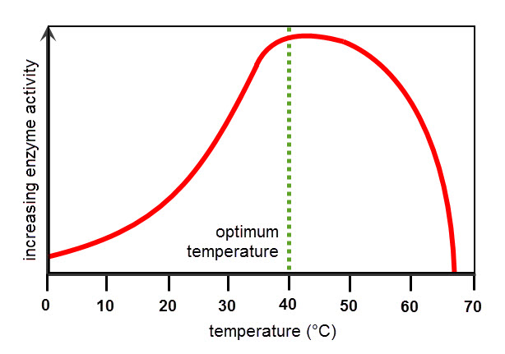Hyperthermia is a condition where the core temperature of the body increases so high that a person suffers from a fever or even death. The graph below shows the relationship between core body temperature and enzyme action.

What is happening to the enzyme action of a person suffering hyperthermia and why?

* 1. Increases – due to decrease in activation energy.
  2. Increases – due to increased concentration of enzymes.
  3. Decreases – due to decreased cell permeability.
  4. Decreases – due to enzymes denaturing.

1. In which of the following would you expect blood pressure to be at its highest?
2. The pulmonary artery
3. The aortic arch
4. The inferior vena cava
5. A capillary in your finger
6. Which of the following is not a function of the nasal cavity?
7. Warm and filter air
8. Act as a resonating chamber for sound
9. Provide a surface to detect odours
10. Channel air into the trachea and not the oesophagus

**SHORT ANSWER SECTION [38 MARKS]**

This section has **nine** questions. Answer all questions in the spaces provided.

**Question 1** **[13 marks]**

Below is a cross-sectional diagram of a human heart

II

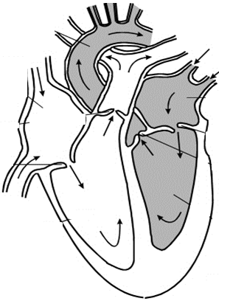

V

III

I

IV

1. Label the following structures: *[2 marks]*

II __________________________________________________

V __________________________________________________

1. Explain what would happen to structures I and IV during diastole and atricular systole.

*[2 marks]*

________________________________________________________________________________________________________________________________________________________________________________________________________________________________________________________________________________________________________________________

1. Your heart is made of muscular tissue. State two types of tissue found in your finger *[1 mark]*

_______________________________________________________________________________

1. Sometimes babies can be born with a hole connecting the two atria of the heart. Using your knowledge of the circulatory system, explain why a ‘hole in the heart’ is a serious problem.  *[2 marks]*

___________________________________________________________________________________________________________________________________________________________________________________________________________________________________________________________________________________________________________________________________________________________________________________________________________________________________________________________________________________

1. State and explain two ways that red blood cells are perfectly structured for their function of carrying oxygen. *[4 marks]*

________________________________________________________________________________________________________________________________________________________________________________________________________________________________________________________________________________________________________________________________________________________________________________________________________________________________________________________________________________________________________________________________________________________________________________

1. Bicarbonate ions are the product of a chemical reaction within the body. Explain how these ions are formed.  *[2 marks]*

______________________________________________________________________________________________________________________________________________________________________________________________________________________________________________________________________________________________________________________________

**Question 2 [9 marks]**

* 1. With reference to the lymphatic system, explain why exercising can reduce the chances of you getting a bacterial infection. *[3 marks]*

_____________________________________________________________________________________________________________________________________________________________________________________________________________________________________________________________________________________________________________________________________________________________________________________________________

* 1. When any blood vessel is damaged, blood escapes and after a few minutes the blood flow stops as it thickens and forms a clot. Outline **four (4)** events occurring in the blood vessel and blood which stop the bled.  *[4 marks]*

_____________________________________________________________________________________________________________________________________________________________________________________________________________________________________________________________________________________________________________________________________________________________________________________________________________________________________________________________________________________________________________________________________________________________________________________________________________________________________________________________________________________________________________________________________________________________________________________________________________________________________________________________________________________________________________________________________________________________________________________________________________________________________________________

* 1. A person is involved in a crash accident, out on the Eyre Highway. Because he is losing blood fast the paramedics decide to he needs to be given blood to replace what he has lost. Unfortunately, the person is unable to talk and cannot tell paramedics what blood group he has. What blood could he be given and describe why.  *[2 marks]*

______________________________________________________________________________________________________________________________________________________________________________________________________________________________________________________________________________________________________________________________________________________________________________________________________

**Question 3 [7 marks]**

1. 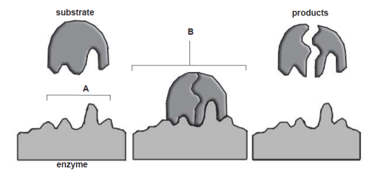The following question refers to the diagram below, which shows the events that occur during a reaction involving an enzyme.
2. State whether the reaction shown in the diagram is a catabolic or anabolic reaction, and explain how you know.  *[2 marks]*

______________________________________________________________________________________________________________________________________________________

1. 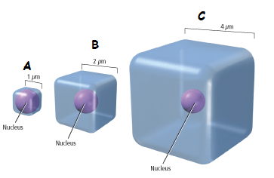The following question refers to the diagram below.
2. Which of the cells in the diagram above (A, B or C) would supply its organelles with the substances they require most efficiently? Explain your reasoning.  *[2 marks]*

_________________________________________________________________________________________________________________________________________________________________________________________________________________________________

1. The table below shows the change in mass of the eggs overnight in the three different solutions. Use the information to answer the following question.

|  |  |  |  |
| --- | --- | --- | --- |
| Egg | Start mass (g) | Final mass (g) | Difference (g) |
| 1 | 59.9 | 53.2 | - 6.7 |
| 2 | 58.4 | 63.6 | 5.2 |
| 3 | 57.4 | 57.5 | 0.1 |

One of the eggs was placed in concentrated sugar syrup. From the data provided, identify which egg this was and explain why its weigh changed. *[3 marks]*

_____________________________________________________________________________________________________________________________________________________________________________________________________________________________________________________________________________________________________________________________________________________________________________________________________________________

**Question 4 [9 marks]**

Below is a diagram of the internal structure of the lungs.

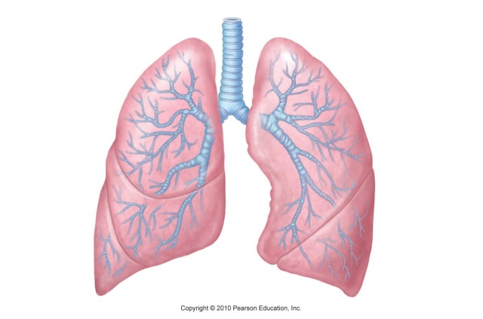

1. The lung is a very good example of a surface which enables exchange of materials to occur efficiently in the human body. Describe two features of the lungs that make them well-suited to gas exchange. *[2 marks]*

1. ____________________________________________________________________________

______________________________________________________________________________

2. ____________________________________________________________________________

______________________________________________________________________________

1. The trachea and bronchi have C-shaped cartilage surrounding them. What is the purpose of the cartilage?  *[1 mark]*

____________________________________________________________________________________________________________________________________________________________

1. Identify the main structures that have a role in the movement of air into the lungs. Describe the role played by each structure. *[6 marks]*

_____________________________________________________________________________________________________________________________________________________________________________________________________________________________________________________________________________________________________________________________________________________________________________________________________________________________________________________________________________________________________________________________________________________________________________________________________________________________________________________________________________________________________________________________________________________________________________________________________________________________________________________________________________________________________

**EXTENDED ANSWER SECTION [10 MARKS]**

Laura is an avid cyclist. Each morning she wakes up early and goes for a 1 hour cycle. Her leg muscles have become very efficient at using oxygen to make the energy she needs to continue cycling.

Explain, in detail, the process that the mitochondria in her leg muscles are going through to produce these large quantities of energy. In your answer, include a description of how the oxygen needed for this process moves from the outside world to the mitochondria in her legs.

________________________________________________________________________________________________________________________________________________________________________________________________________________________________________________________________________________________________________________________________________________________________________________________________________________________________________________________________________________________________________________________________________________________________________________________________________________________________________________________________________________________________________________________________________________________________________________________________________________________________________________________________________________________________________________________________________________________________________________________________________________________________________________________________________________________________________________________________________________________________________________________________________________________________________________________________________________________________________________________________________________________________________________________________________________________________________________________________________________________________________________________________________________________________________________________________________________________________________________________________________________________________________________________________________________________________________________________________________________________________________________________________________________________________________________________________________________________________________________________________________________________________________________________________________________________________________________________

________________________________________________________________________________________________________________________________________________________________________________________________________________________________________________________________________________________________________________________________________________________________________________________________________________________________________________________________________________________________________________________________________________________________________________________________________________________________________________________________________________________________________________________________________________________________________________________________________________________________________________________________________________________________________________________________________________________________________________________________________________________________________________________________________________________________________________________________________________________________________________________________________________________________________________________________________________________________________________________________________________________________________________________________________________________________________________________________________________________________________________________________________________________________________________________________________________________________________________________________________________________________________________________________________________________________________________________________________________________________________________________________________________________________________________________________________________________________________________________________________________________________________________________________________________________________________________________

________________________________________________________________________________________________________________________________________________________________________________________________________________________________________________________________________________________________________________________________________________________________________________________________________________________________________________________________________________________________________________________________________________________________________________________________________________________________________________________________________________________________________

_________________________________________________________________________________________________________________________________________________________________________________________________________________________________________________________________________________________________________________________________________________________________________________________________________________________________________

_______________________________________________________________________________________________________________________________________________________________________________________________________________________________________________________________

***END OF TEST***